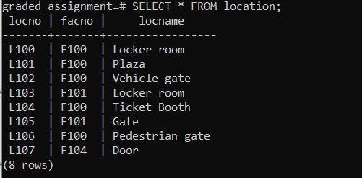

INSERT INTO location (locno, facno, locname)

VALUES ('L107', 'F104', 'Door');